Stroke Risk Prediction Model
COM 763 – Advanced Machine Learning | Portfolio Task 1

1. Problem Definition and System Framing
Stroke is among the leading causes of death and long-term disability across the world. According to the World Health Organization, around 15 million people suffer a stroke each year, of whom roughly 5 million die and another 5 million are left permanently disabled (Feigin et al., 2022). Early identification of high-risk individuals gives clinicians an opportunity to intervene before the event occurs.
The goal of this project is to build a binary classification system that takes patient demographic and clinical data as input and outputs a stroke risk probability. The dataset used comes from Kaggle's healthcare stroke prediction collection, containing 5,110 patient records across 12 features including age, hypertension status, heart disease, average glucose level, BMI, smoking history, and work type.
The problem is treated as a supervised binary classification task, where each patient is labeled as stroke (1) or no stroke (0). Since the dataset is highly imbalanced (about 4.9% positive cases), this skew must be accounted for during design and evaluation. In this context, accuracy is not very meaningful; the main focus is recall for the stroke class, since missing a stroke is far more critical than a false alarm.

2. Data Pipeline and Feature Handling

2.1 Data Loading and Initial Exploration
The dataset was loaded using Pandas. The initial exploration confirmed 5,110 rows and 12 columns. Summary statistics revealed that the age distribution spans from near-zero to 82 years, with a mean around 43. Average glucose level has a wide range (55 to 271), and BMI has a right-skewed distribution with some extreme values. The patient ID column carries no predictive information and was dropped before modelling.
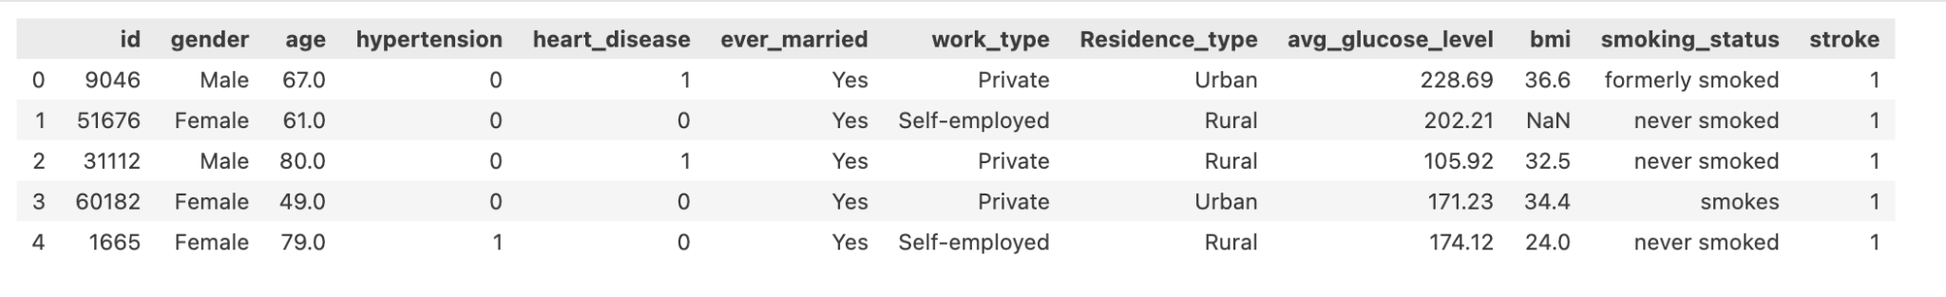Figure 1: first five rows showing feature structure and sample values

2.2 Missing Values
Only one feature had missing values: BMI, with 201 missing entries, or roughly 3.9% of the dataset. Rather than dropping these rows and losing potentially useful records, median imputation was applied within a preprocessing pipeline. Median was preferred over mean because the BMI distribution is slightly skewed, making the median a more robust central tendency measure.
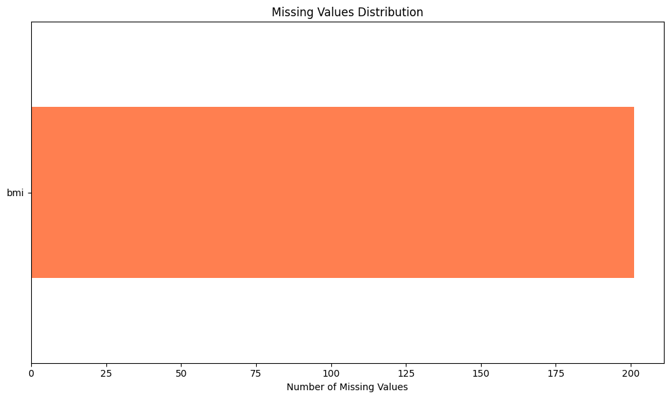
Figure 2: Missing values distribution – only BMI contained null entries (201 records, 3.93%)

2.3 Class Imbalance Analysis
The target distribution showed a pronounced imbalance. Of 5,110 records, only 249 patients experienced a stroke, giving a positive class prevalence of 4.87%. This is a serious practical issue: a model that simply predicts "no stroke" for every case would achieve 95% accuracy while being completely useless clinically. The imbalance was addressed using SMOTE (Synthetic Minority Oversampling Technique), applied inside the training pipeline to avoid data leakage to the test set.
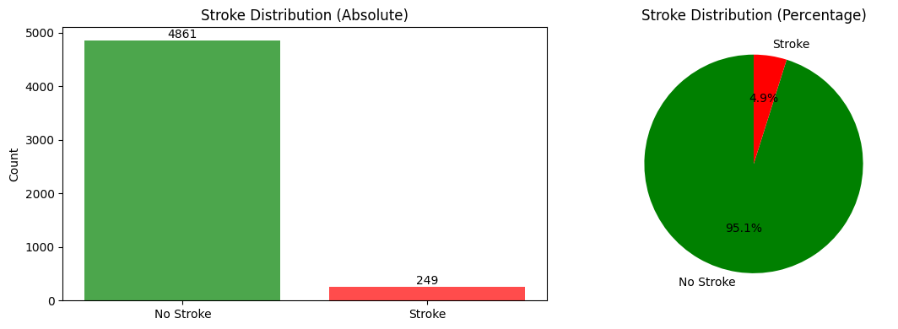
Figure 3: Stroke class distribution – 4,861 no-stroke cases vs 249 stroke cases (4.87% positive prevalence)

2.4 Exploratory Data Analysis
Box plots of the three numerical features: age, average glucose level, and BMI segmented by stroke outcome, showed that age has the clearest separation between the two groups. Stroke patients in the dataset tend to be considerably older, with a median age noticeably higher than non-stroke patients. Glucose level shows some separation, while BMI differences between the two groups are minimal. This suggested age would likely be the most important predictor.
Correlation analysis confirmed this. Age had the strongest positive correlation with stroke (r = 0.245), followed by heart disease (r = 0.135) and average glucose level (r = 0.132). Hypertension was also positively correlated (r = 0.128). Being a child (work_type = "children") was negatively correlated, which makes intuitive sense. BMI alone had very weak correlation (r = 0.036).
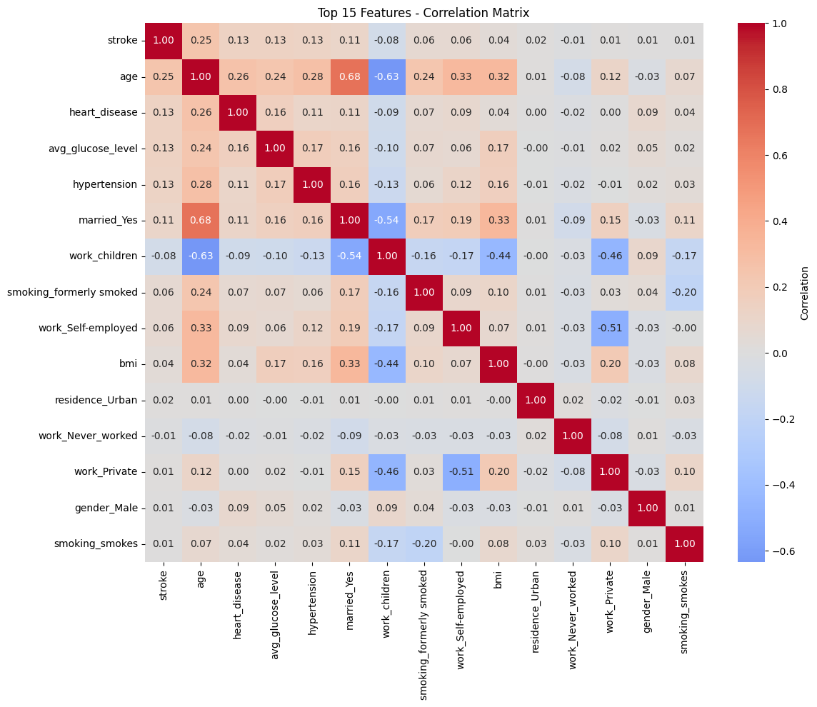
Figure 4: Correlation heatmap for the top 15 features

2.5 Feature Engineering and Preprocessing
The preprocessing pipeline treated numerical and categorical features separately using a ColumnTransformer. Numerical columns (age, average glucose level, BMI) were processed through a pipeline that first applied median imputation to handle BMI's missing values, then applied StandardScaler to normalise the feature ranges. Without scaling, regularised models like Logistic Regression would penalise features with larger numeric ranges disproportionately.
Categorical columns (gender, ever_married, work_type, Residence_type, smoking_status) were passed through a separate pipeline using most-frequent imputation followed by OneHotEncoder with handle_unknown='ignore'.
This produced a final feature matrix of 17 columns after encoding. The full preprocessing was embedded inside each model pipeline, ensuring the same transformations were applied consistently during cross-validation and test evaluation without any leakage.

3. Model Implementation

3.1 Model Selection Rationale
Three models were implemented and compared.
Logistic Regression was included as a baseline because it is interpretable and well-understood. It also handles class imbalance reasonably well with the class_weight='balanced' parameter.
Random Forest was chosen as a non-linear ensemble method that is less sensitive to feature scaling and can capture complex variable interactions.
Gradient Boosting completed the trio as a sequential ensemble approach known to produce strong results on tabular data.

3.2 Data Splitting and Pipeline Construction
The data was split 80/20 into training and test sets using stratified sampling (stratify=y), which preserves the class ratio in both splits.
All three models used the same split to ensure fair comparison, SMOTE was then applied inside each pipeline after preprocessing but before the model, using imbalanced-learn's ImbPipeline class.
3.3 Model 1: Logistic Regression
The Logistic Regression model was configured with max_iter=1000 to ensure convergence and class_weight='balanced' to compensate for the skewed class distribution. Five-fold stratified cross-validation on the training set produced a mean ROC-AUC of 0.8359, with a standard deviation of 0.0109 a fairly stable result. On the held-out test set, the model achieved a ROC-AUC of 0.845, recall of 0.80 for the stroke class, and an F1-score of 0.237. The low precision (0.139) reflects that the model generates many false positives in exchange for high sensitivity.

3.4 Model 2: Random Forest
Random Forest was configured with 100 trees, a maximum depth of 20, and minimum sample requirements (min_samples_split=10, min_samples_leaf=5) to prevent overfitting. Class weights were set to balance. Cross-validation gave a mean ROC-AUC of 0.8042, slightly below Logistic Regression. On the test set, however, the model achieved only 0.409 ROC-AUC. The forest had high accuracy (90.2%) but that figure is misleading in the context of class imbalance; its recall on the stroke class dropped to just 0.26..

3.5 Model 3: Gradient Boosting
Gradient Boosting was configured with 100 estimators, a learning rate of 0.1, max_depth of 5, and subsample of 0.8 to introduce stochasticity and reduce overfitting. Cross-validation ROC-AUC was 0.7877 with the highest variability of the three models (±0.0214), which raised some concern about stability. On the test set, it achieved ROC-AUC of 0.440 and recall of 0.24 on the stroke class , the weakest sensitivity performance among the three models.

4. Experimental Evaluation and Model Selection

4.1 Cross-Validation Results
The table below summarises 5-fold stratified cross-validation ROC-AUC scores on the training set. All three models were evaluated before fitting on the full training data to avoid optimistic bias.
Model | Mean CV ROC-AUC | Std Dev
Logistic Regression | 0.8359 | ±0.0109
Random Forest | 0.8042 | ±0.0114
Gradient Boosting | 0.7877 | ±0.0214
Table 1: 5-fold cross-validation ROC-AUC results
Logistic Regression led cross-validation by a meaningful margin. The gradient boosting model showed greater variance across folds, which could indicate sensitivity to the random sampling of SMOTE minority examples within each fold.

4.2 Test Set Performance
The table below shows the full set of evaluation metrics computed on the held-out test set (n = 1,022 records, 50 stroke cases, 972 non-stroke cases).

Table 2: Model comparison on held-out test set
Model | Accuracy | Precision | Recall | F1-Score | ROC-AUC
Logistic Regression | 74.8% | 13.9% | 80.0% | 0.237 | 0.845
Random Forest | 90.2% | 17.1% | 26.0% | 0.206 | 0.409
Gradient Boosting | 90.9% | 17.9% | 24.0% | 0.205 | 0.440
The results tell an interesting story. Logistic Regression achieves the highest ROC-AUC (0.845) and the highest recall (0.80), meaning it correctly identifies 40 of the 50 stroke cases in the test set. Its precision is low (0.139), which is expected: in a heavily imbalanced problem, a model tuned for sensitivity will produce many false positives. For a clinical screening tool this trade-off is acceptable further diagnostic tests can filter false alarms, but a missed stroke cannot be undone.
Random Forest and Gradient Boosting achieve high overall accuracy but their ROC-AUC scores fall below 0.5 on the test set, meaning their probability scores are essentially worse than random for ranking stroke risk. This is a failure mode that masks high accuracy masks completely. A model with 90.9% accuracy that has a ROC-AUC of 0.44 is actively harmful for a ranking or screening application.
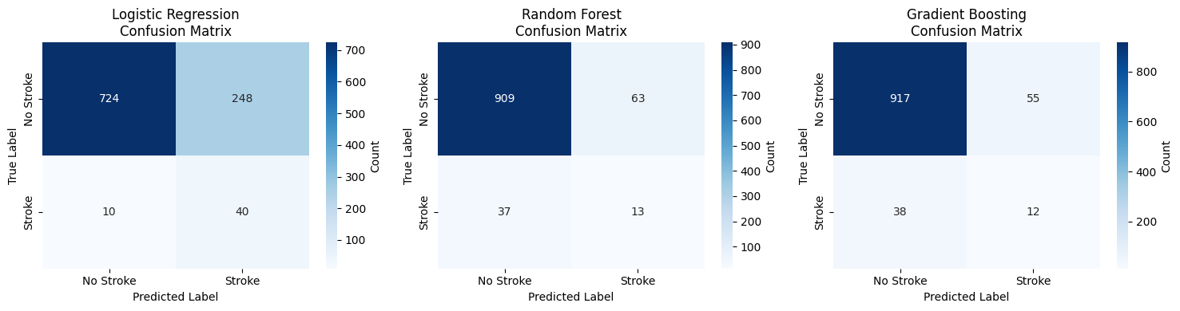
Figure 5: Confusion matrices for all three models

4.3 ROC and Precision-Recall Curves
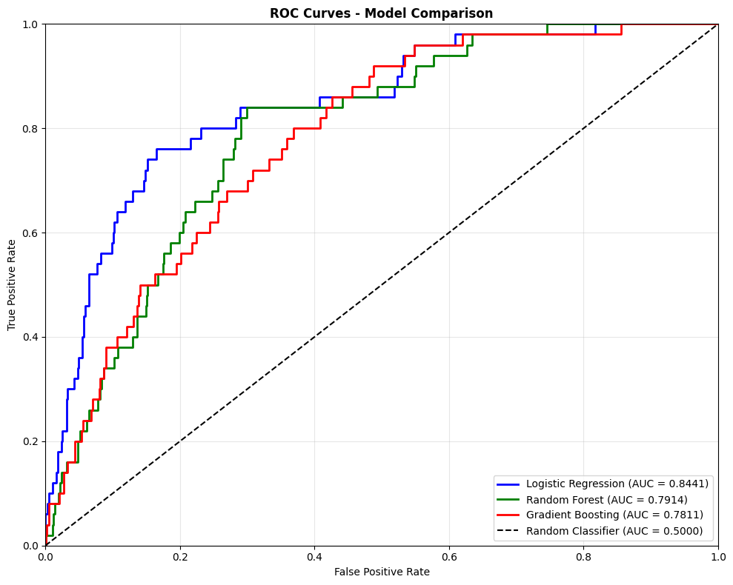
Figure 6: ROC curves comparing all three models 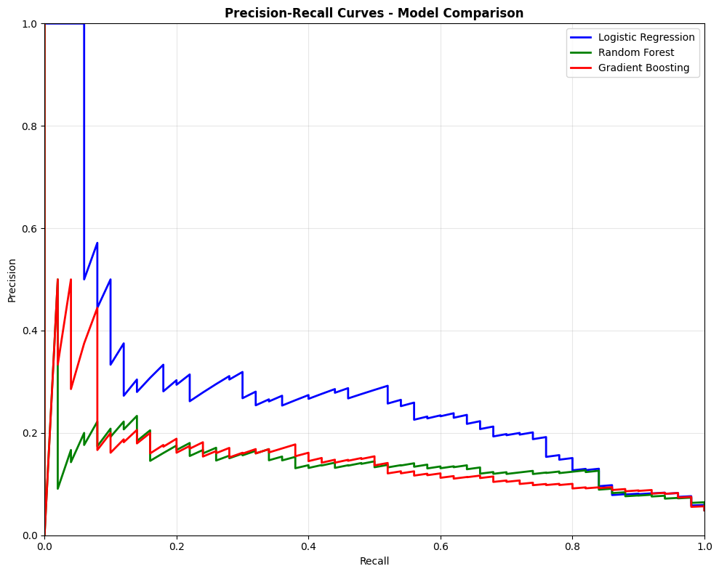
Figure 7: Precision-Recall curves
The ROC curves make the decision clear. Logistic Regression traces a substantially higher curve than both tree-based models. Gradient Boosting and Random Forest both dip below the diagonal in places, which means their predicted probabilities have poor calibration on this test set. This could be caused by SMOTE-generated synthetic examples that the tree models fit too closely during training, producing poorly calibrated probability outputs when evaluated on real minority examples.

4.4 Feature Importance
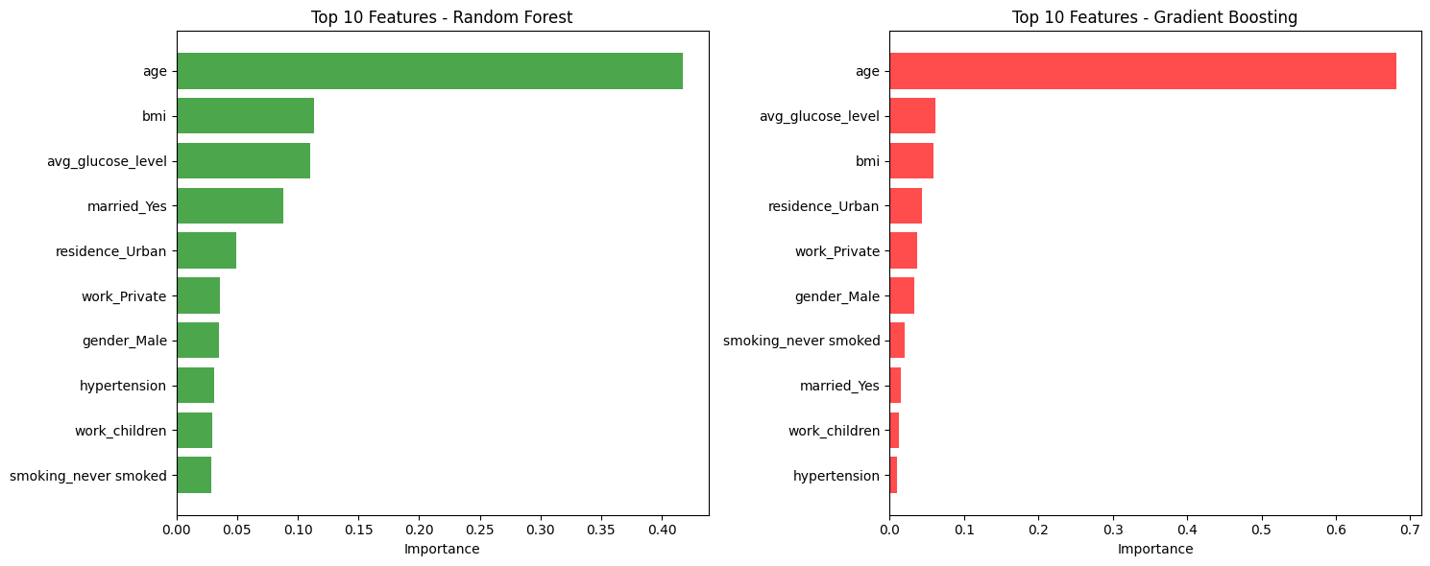
Figure 8: Feature importance
The Random Forest feature importances confirm what the correlation analysis suggested: age is by far the most influential predictor, contributing over 40% of the importance score. Average glucose level and BMI follow as the next most important numerical features. Among categorical variables, work_type (particularly the children category, which acts as a proxy for young age) and smoking history contribute modestly. Hypertension and heart disease, while clinically meaningful, rank lower in feature importance likely because their effect is partially captured by age in this dataset.

4.5 Final Model Selection
Logistic Regression is selected as the final model. The reasoning is straightforward: it achieves the highest ROC-AUC (0.845 on the test set), the highest recall on stroke cases (0.80), and stable cross-validation performance. In a medical screening context, recall is the metric that matters most. A false negative missing a stroke has far more serious consequences than a false positive that leads to a follow-up consultation. Logistic Regression also has the advantage of producing well-calibrated probability scores, which are more useful clinically than raw class predictions.

5. Deployment
The final Logistic Regression model, along with its full preprocessing pipeline, was serialised using Python's pickle library. The application was deployed on Streamlit Community Cloud, where users can input patient details age, hypertension status, heart disease, glucose level, BMI, smoking status, and work type and receive a stroke probability score along with a risk classification.
The Streamlit interface is intentionally minimal. Users enter clinical values through form inputs, and the application returns a probability between 0 and 1 along with a simple risk label. The full preprocessing pipeline is loaded alongside the model, ensuring that any new input goes through the same imputation, scaling, and encoding steps that the training data experienced. No raw data is stored by the application.
Deployed application URL: [https://stroke-prediction-ml.streamlit.app]

References
Feigin, V.L., Brainin, M., Norrving, B., Martins, S., Sacco, R.L., Hacke, W., Fisher, M., Pandian, J. and Lindsay, P. (2022) "World Stroke Organization (WSO): global stroke fact sheet 2022," International Journal of Stroke, 17(1), pp. 18–29. Available at: https://doi.org/10.1177/17474930211065917
Lemaître, G., Nogueira, F. and Aridas, C.K. (2017) "Imbalanced-learn: a Python toolbox to tackle the curse of imbalanced datasets in machine learning," Journal of Machine Learning Research, 18(17), pp. 1–5. Available at: http://jmlr.org/papers/v18/16-365.html

